**Westpac Practical Test**

**1.** [**https://buggy.justtestit.org/**](https://buggy.justtestit.org/) **- Using this website, consider below scenario:**

**Scenario: Create a script that browse among Popular Make (Lamborghini) -> select one and click of the Model -> browse on the page and validate proper response**

*After that:*

*• Upload the solution to a public shared repository e.g. GitHub*

*• Upload the test approach and bugs logged to the same repository*

*• Write clear instructions on how to execute the test*

*• Mention any prerequisites / Setup Information for the test*

*• Tools that may be required to execute the test*

*Performance Test Setup*

1. *Tool required JMeter version 5+*
2. *Data file needs to be loaded into data folder   
   I.e apache-jmeter-5.2.1/data/* ***lambomodelsparams.csv***

**2. Buggy Cars Rating website - *Test Approach and Strategy***

* Performance testing team (I) will create the scripts required to run the workload defined by project (See Buggy Cars Rating website Performance Testing - Workload) .
* Proposed NFR and SLA have been provided by Buggy stakeholders. Performance test team will present the results found after Baseline test to Platform team who will approve and/or accept the results as per internal review.
* Test design is expected to resemble production like conditions. The assumption is that Buggy Cars Rating website is 1 : 1 to production
* The Performance test approach provides a framework within which the test effort for this test phase can be controlled, coordinated, prioritized, monitored, measured and audited.
* Test Entry and Exit criteria is detailed below
* The below flow diagram explains the Performance Test approach for Buggy website.

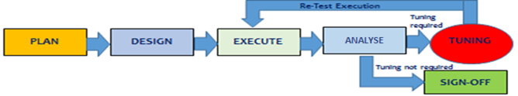

* **Buggy Cars Rating Website Performance Testing – *Workload***

**Workload used**

1. **Step 1 , 2 Concurrent users holding load 3 minutes ( No Ramp up)**
2. **Step 2 , 5 Concurrent users holding load 3 minutes ( No Ramp up)**
3. **Step 3 , 10 Concurrent users holding load 3 minutes ( No Ramp up)**
4. **Step 4 , 20 Concurrent users holding load 3 minutes ( No Ramp up)**

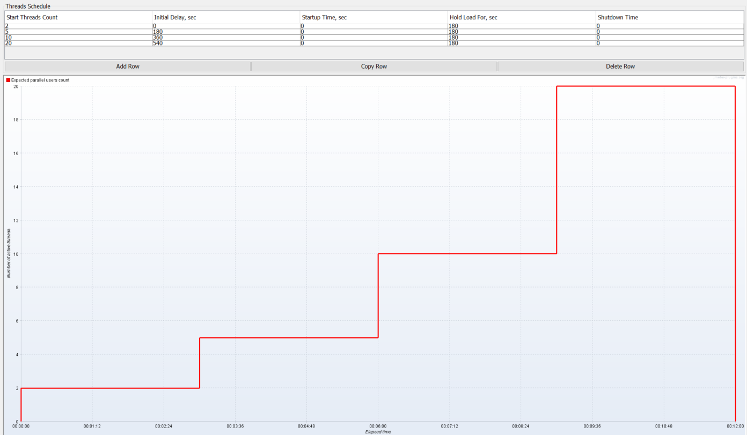

* **Buggy Cars Rating Website Performance Testing – Non-Functional Requirements (NFR)**

|  |  |  |  |  |
| --- | --- | --- | --- | --- |
| **Req ID** | **Name of the Requirement** | **Detail** | **Req Provider** | **Priority** |
| PTBCR.001 | User concurrency supported by website | Buggy cards rating website must support the connection of 10 concurrent uses | Buggy Tech team | H |
| PTBCR.002 | SLA / Response time acceptance | Buggy cards rating website response time must be under 2 seconds with 10 users in the system | Buggy Tech team | H |

* **Buggy Cars Rating Website Performance Testing – Entry and Exit Criteria**

**Entry Criteria**

Component Performance Testing:

* Functional testing has been concluded and no further breaking changes are introduced on the interfaces.
* Buggy Cars Rating Performance test plan has been reviewed and signed off by all reviewers (including in the stakeholder approvals table)
* All Performance checklist items to conduct tests have been met.

**Exit Criteria**

Component Performance Testing:

* Buggy Cars Rating Performance testing results meet the evaluation criteria specified by Tech team.
* All the performance testing execution artefacts are submitted to Tech team from Performance test (I) team.
* Test results along with risks are agreed and signed off by project stakeholders (Business).

**2. Create script in JMeter**

* *Westpac_Jmeter_TestPlan_Jul2021.jmx*

**3. Run this script for concurrent 2 , 5, 10 and 20 users.**

**4. Results attached**

* *Raw_Results_Westpac_Test_20210726-102257.csv*

**5. Analyse and summarize the results based on website**

**Quick Analysis and Summary**

**Summary**

* Test Execution 1 from 10:22 AM pm to 10:29 AM NZT with a maximum of 20 concurrent users.
* **Step Test** Design: Start with 2 Concurrent users then ramp up to; 5, 10 and 20 users. I am holding the load for 3 minutes before moving to each next step.
* **Ramp up**:   I did not add any ramp up because it is just a simple practical test.
* **Maximum of 20** concurrent users.
* **Response time** : Based on raw results , high level breakdown of response time for Average and 90th Percentile per Step. (Each step runs for 3 minutes) Chart below for whole test.

|  |  |  |  |  |  |  |
| --- | --- | --- | --- | --- | --- | --- |
| Step | Concurrent Users | Start Time (Pm) | End Time (Pm) | Count | Average Response Time (Seconds) | 90th Percentile (Seconds) |
| 1 | **2** | 10:22 | 10:25 | 205 | 368.23 | 846 |
| 2 | **5** | 10:25 | 10:28 | 608 | 361.86 | 836.10 |
| 3 | **10** | 10:28 | 10:29 | 432 | 280.43 | 820.70 |
| 4 | **20** |  |  |  |  |  |

* **Error Summary** :  Low error rate for this test, only 115 Errors observed.

Breakdown of errors per Transaction.

|  |  |  |
| --- | --- | --- |
| **Transaction** | **#Samples Total Count** | **Error Detail** |
| **Homepage_02** | 30 | Non HTTP response code: java.net.SocketException/Non HTTP response message: Socket operation on nonsocket: connect |
| **selectLambosModels_3** | 42 | Non HTTP response code: java.net.SocketException/Non HTTP response message: Socket operation on nonsocket: connect |
| **selectPopularMakeLambo_02** | 39 | Non HTTP response code: java.net.SocketException/Non HTTP response message: Socket operation on nonsocket: connect |
| **Total** | **115** | 1 |

**Detailed Results**

* Detailed results extracted from JMeter , Note: Count in Samples contain transaction.

**Statistics**

| **Requests** | **Executions** | | | **Response Times (ms)** | | | | | | **Throughput** | **Network (KB/sec)** | |
| --- | --- | --- | --- | --- | --- | --- | --- | --- | --- | --- | --- | --- |
| **Label** | **#Samples** | **KO** | **Error %** | **Average** | **Min** | **Max** | **90th pct** | **95th pct** | **99th pct** | **Transactions/s** | **Received** | **Sent** |
| **Total** | **1247** | **115** | **9.22%** | **334.24** | **0** | **1855** | **832.40** | **882.60** | **1115.64** | **3.13** | **24.65** | **1.30** |
| Homepage_01 | 627 | 30 | 4.78% | 166.73 | 0 | 1099 | 271.00 | 299.20 | 638.08 | 1.57 | 2.49 | 0.85 |
| Homepage_02 | 310 | 30 | 9.68% | 169.76 | 113 | 746 | 196.90 | 219.00 | 626.05 | 0.78 | 0.59 | 0.33 |
| SelectLambosModels_3 | 606 | 88 | 14.52% | 365.42 | 0 | 1407 | 891.80 | 948.00 | 1158.61 | 1.54 | 41.72 | 0.71 |
| SelectPopularMake_02 | 310 | 39 | 12.58% | 721.20 | 0 | 1855 | 878.90 | 926.80 | 1746.30 | 0.78 | 2.42 | 0.36 |
| SelectPopularMakeLambo_02 | 308 | 39 | 12.66% | 716.12 | 30 | 1824 | 876.10 | 909.10 | 1450.40 | 0.78 | 2.42 | 0.36 |

**Response Time Over Time**

<https://buggy.justtestit.org> capacity is reached when running 5 concurrent users and load pushed to 6 request per second, at that moment a high number of different errors is presented. It was not possible to push load to 20 concurrent users as original planned.

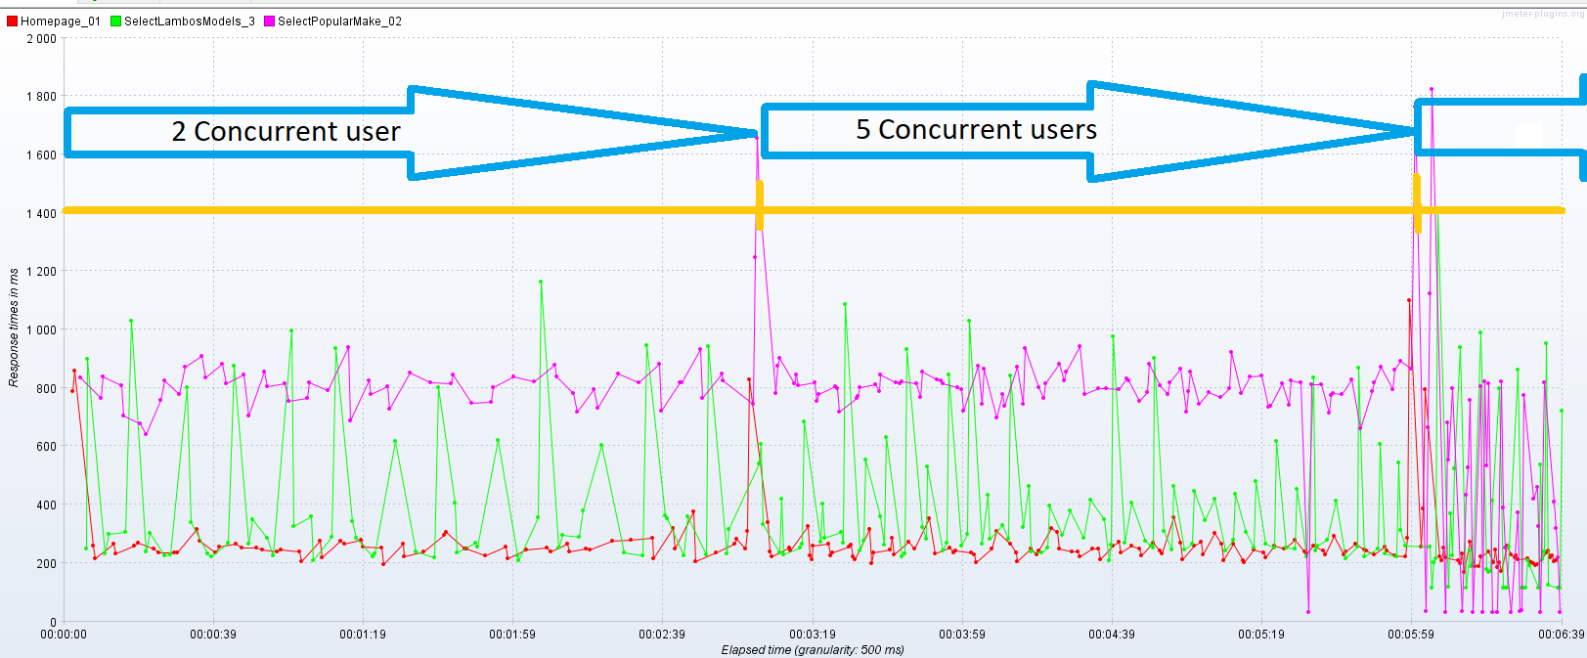

**Transactions per second**

* 6 TPS was the Maximum Transactions per second observed during test

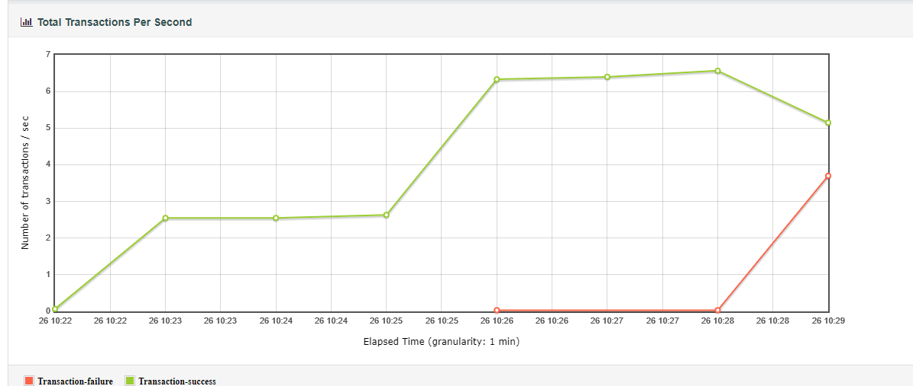

**Bytes throughput over time**

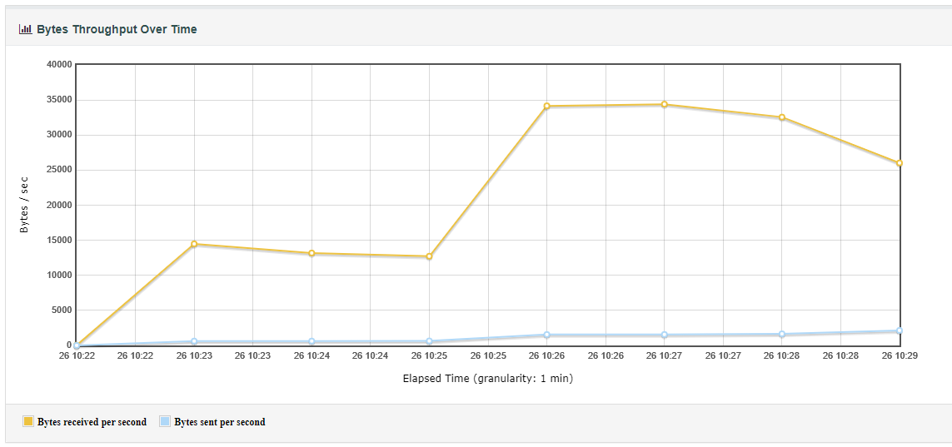

1. **Defects found**

Defects reported were focused on Performance testing and only 1 functional testing

|  |  |  |  |  |  |  |
| --- | --- | --- | --- | --- | --- | --- |
| Defect ID | Summary | Severity | Priority | Assigned To | Creation Date | Status |
| DEF-1 | User concurrency not met  (Performance Defect) | High | High | Person | 26/10/2021 | In Progress |
| DEF-2 | Registration flow fails  (Functional defect) | High | High | Person | 26/10/2021 | In Progress |